

RAILROAD
ACCESSORIES

Table 1 Lifting Hook
Table 2 Rotator 360 ° Continuous
Table 3 Clamshell Bucket Ballast
Table 4 Clamshell Bucket Between Sleepers
Table 5 Backhoe Bucket
Table 6 Backhoe Cleaning Bucket
Table 7 Bush & Grass Mower
Table 8 Rails Grab
Table 9 Sleepers Grab
Table 10 Sleepers Hydraulic Beam
Table 11 Sleepers Chain Beam
Table 12 Tamping Unit
Table 13 Magnet/Generator
Table 14 Hydraulic Breaker
Table 15 Ballast Broom
Table 16 Pallets Handling Fork
Table 17 Grapple
Table 18 Drilling Device
Table 19 Offset Boom

 | Lifting Hook | Table 1
 | Lifting Hook | Page 1/1
HI RAIL CRANE |  |  | T 2400 FS | T 4300 FS  T 7000 FS | T 10000 FS  T 10000 FS-S
TYPE | . |  | 5 T | 7.5 T | 10 T
CAPACITY |  | t  tons | 5  5.5 | 7.5  8.3 | 10  11
WEIGHT |  | Kg  Lbs | 10  22 | 12  25 | 15  33

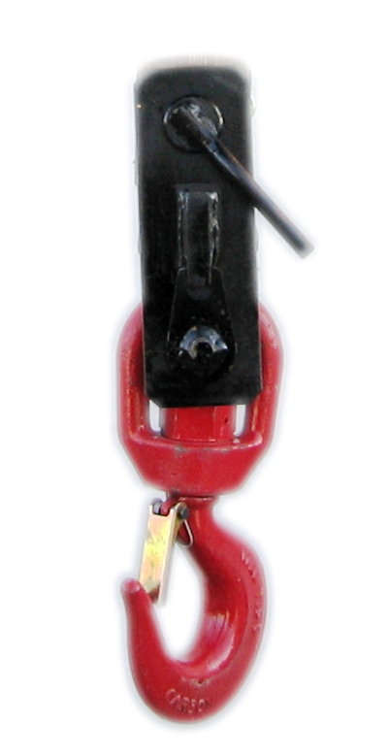

 | Rotator 360 ° Continuous | Table 2
 | Rotator 360 ° Continuous | Page 1/1
HI RAIL CRANE |  |  | T 2400 FS | T 4300 FS  T 7000 FS | T 10000 FS  T 10000 FS-S
TYPE | . |  | OR2-FS | OR2-FS | OR1-FS
CAPACITY |  | t  tons | 7  7.7 | 7  7.7 | 10  11
WEIGHT |  | Kg  Lbs | 250  550 | 250  550 | 270  600

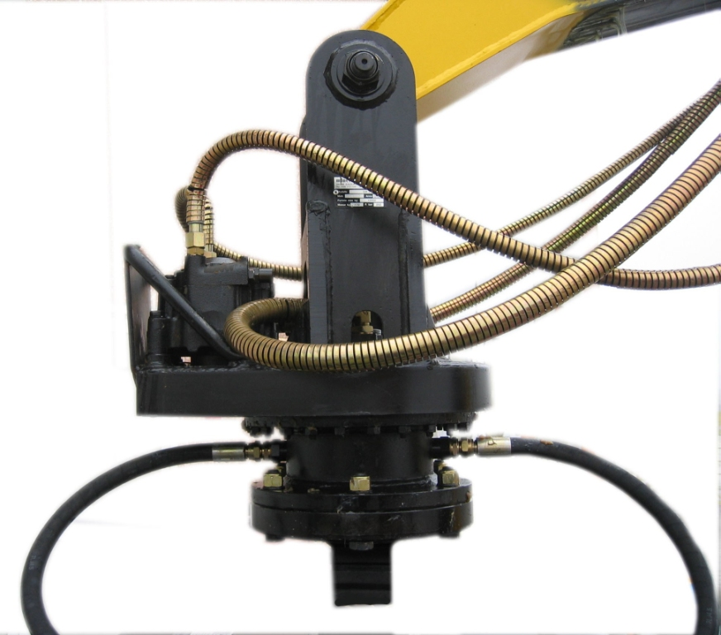

 | Clamshell Bucket Ballast | Table 3
 | Clamshell Bucket Ballast | Page 1/1
HI RAIL CRANE |  |  | T 2400 FS | T 4300 FS  T 7000 FS | T 10000 FS  T 10000 FS-S
TYPE | . |  | R41/700 | R41/1000 | R41/1200
CAPACITY |  | dm³  Cu yd | 500  0.65 | 750  1 | 900  1.2
WEIGHT |  | Kg  Lbs | 680  1500 | 830  1830 | 910  2006
DIMENSIONS | A | mm  in | 1990  78 | 2140  84 | 2140  84
DIMENSIONS | B | mm  in | 2070  81 | 2220  87 | 2220  87
DIMENSIONS | C | mm  in | 1270  50 | 1400  55 | 1400  55
DIMENSIONS | D | mm  in | 1230  48 | 1320  52 | 1320  52
DIMENSIONS | E | mm  in | 1070  42 | 1100  43 | 1100  43
DIMENSIONS | L | mm  in | 840  33 | 1020  40 | 1250  49

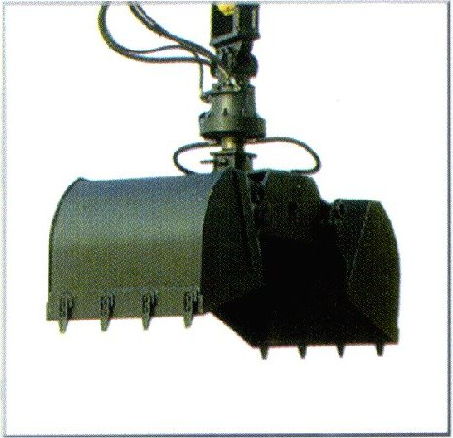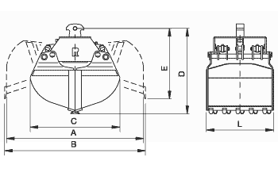

 | Clamshell Bucket Between Sleepers | Table 4
 | Clamshell Bucket Between Sleepers | Page 1/1
HI RAIL CRANE |  | T 2400 FS | T 4300 FS  T 7000 FS | T 10000 FS  T 10000 FS-S
TYPE |  | CS 25 | CS 25 | CS 25
CAPACITY | dm³  Cu ft | 40  1.4 | 40  1.4 | 40  1.4
WEIGHT | Kg  Lbs | 300  660 | 300  660 | 300  660

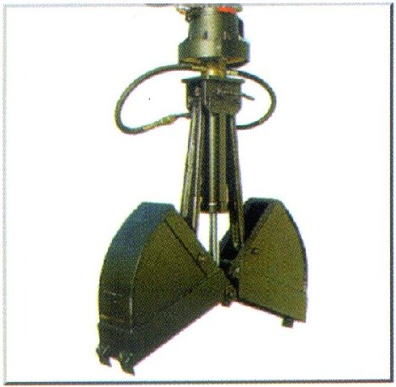
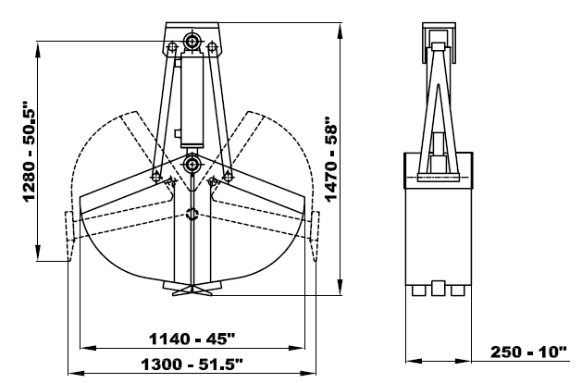

 | Backhoe Bucket | Table 5
 | Backhoe Bucket | Page 1/1
HI RAIL CRANE |  | T 2400 FS | T 4300 FS | T 7000 FS | T 10000 FS-S
WIDTH | mm | 600 | 800 | 800 | 800
WIDTH | in | 24 | 32 | 32 | 32

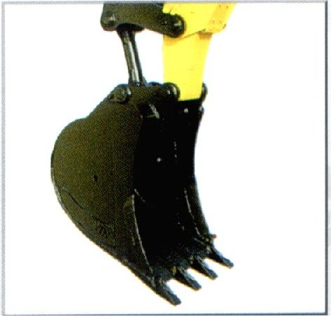
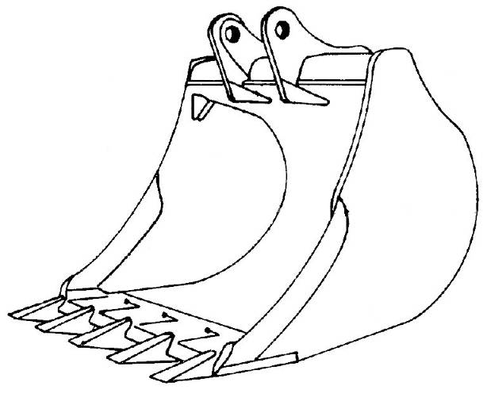
L

 | Backhoe Cleaning Bucket | Table 6
 | Backhoe Cleaning Bucket | Page 1/1
HI RAIL CRANE | T 2400 FS | T 4300 FS | T 7000 FS | T 10000 FS-S
WIDTH (L)
mm | 1500 | 2000 | 2000 | 2000
in | 60 | 80 | 80 | 80
OPENING HEGHT(A)
mm | 620 | 620 | 620 | 620
in | 24 | 24 | 24 | 24

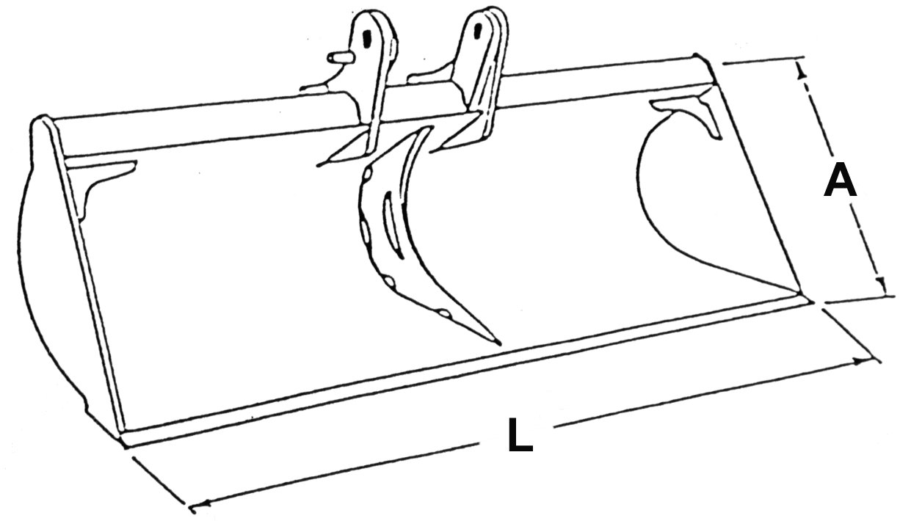

 | Bush & Grass Mower | Tav 7
 | Bush & Grass Mower | Pag 1/1
TYPE |  | TRN 120 FS
CUTTING WIDTH | mm  in | 1240  49
WEIGHT | Kg  Lbs | 400  882

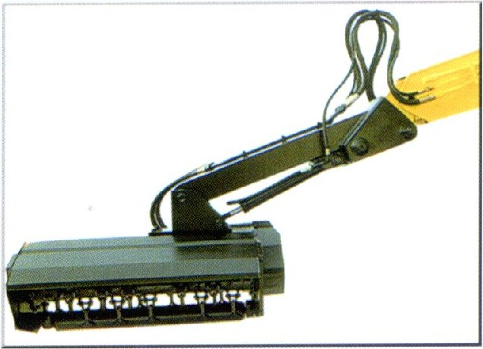
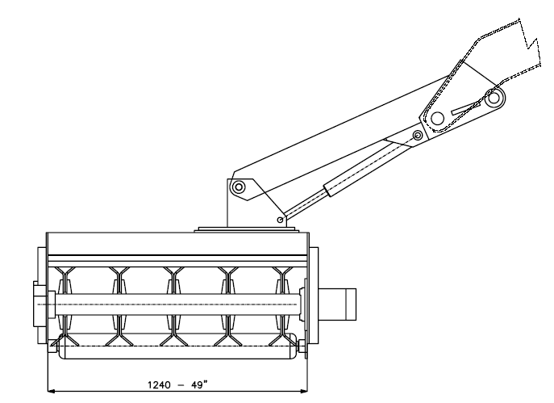

 | Rails Grab | Table 8
 | Rails Grab | Page 1/1
TYPE |  |  | R 55.1
LIFTING CAPACITY |  | Kg  Lbs | 3500  7716
WEIGHT |  | Kg  Lbs | 460  1014
DIMENSIONS | A | mm  in | 1200  47
DIMENSIONS | B | mm  in | 80  4
DIMENSIONS | C | mm  in | 1020  40
DIMENSIONS | D | mm  ft | 640  25
DIMENSIONS | L | mm  in | 1220  48
DIMENSIONS | H | mm  in | 100  4

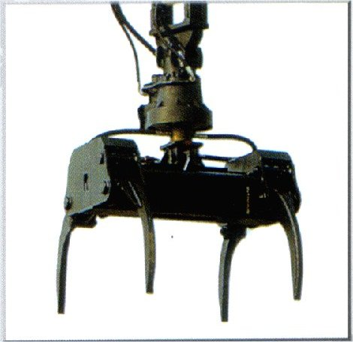
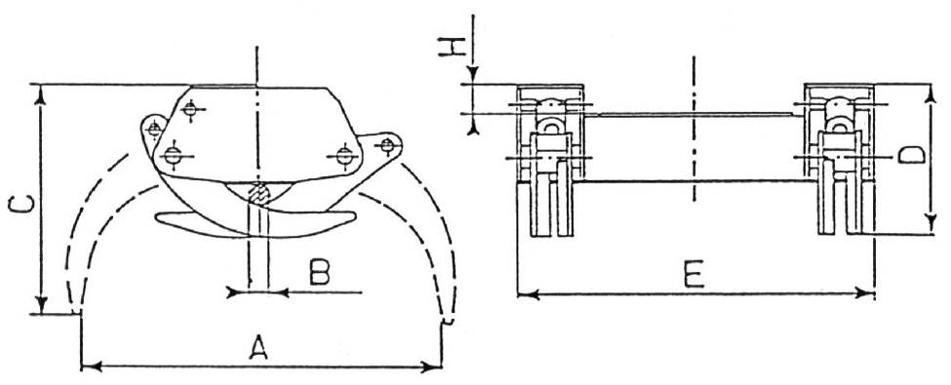

 | Sleepers Grab | Table 9
 | Sleepers Grab | Page 1/1
HI RAIL CRANE |  |  | T 2400 FS | T 4300 FS  T 7000 FS | T 10000 FS  T 10000 FS-S
TYPE |  |  | R 53 LE | R 53 | R 53 PE
LIFTING CAPACITY |  | Kg  Lbs | 3000  6614 | 3000  8818 | 3000  6614
WEIGHT |  | Kg  Lbs | 620  1367 | 730  1609 | 820  1808
DIMENSIONS | A | mm  in | 1960  77 | 2150  85 | 2600  102
DIMENSIONS | B | mm  in | 850  33 | 900  35 | 950  38
DIMENSIONS | C | mm  in | 1070  42 | 1130  44 | 1410  55
DIMENSIONS | D | mm  in | 1080  42 | 1170  4 | 1380  54
DIMENSIONS | L | mm  in | 760  30 | 950  38 | 930  37
DIMENSIONS | F | mm  in | 660  26 | 750  30 | 980  39
DIMENSIONS | S | m²  sq ft | 0.6  6 | 0.7  7 | 0.9  10

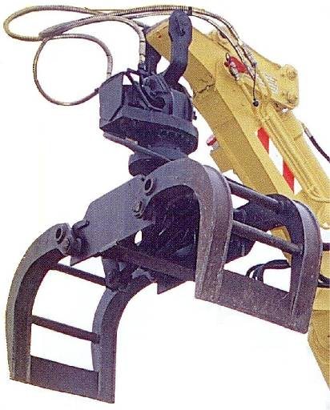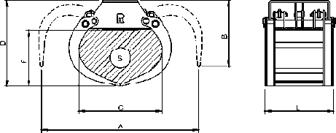

 | Sleepers Hydraulic Beam | Table 10
 | Sleepers Hydraulic Beam | Page 1/1
HI RAIL CRANE |  | T 2400 FS | T 4300 FS | T 7000 FS | T 10000 FS  T 10000 FS-S
SLEEPERS CAPACITY | No. | 6 | 8 | 10 | 20
L | mm  ft | 1800  6’ | 2400  8’ | 3000  10’ | 6000  20’
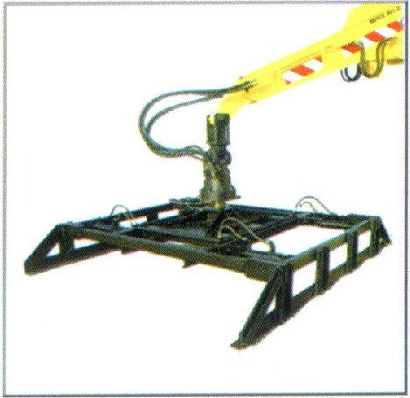
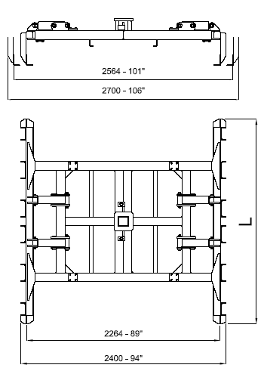

 | Sleepers Chain Beam | Table 11
 | Sleepers Chain Beam | Page 1/1
HI RAIL CRANE |  | T 2400 FS | T 4300 FS | T 7000 FS | T 10000 FS  T 10000 FS-S
SLEEPERS CAPACITY | No. | 7 | 9 | 11 | 19
L | mm  ft | 2500  8’ 4” | 3100  10’ 2” | 3800  12’ 6” | 6700  22’

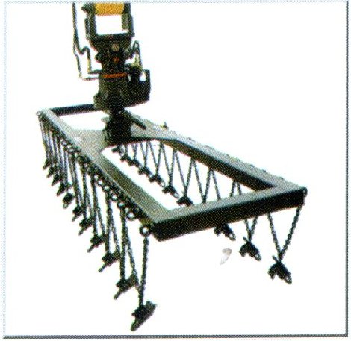
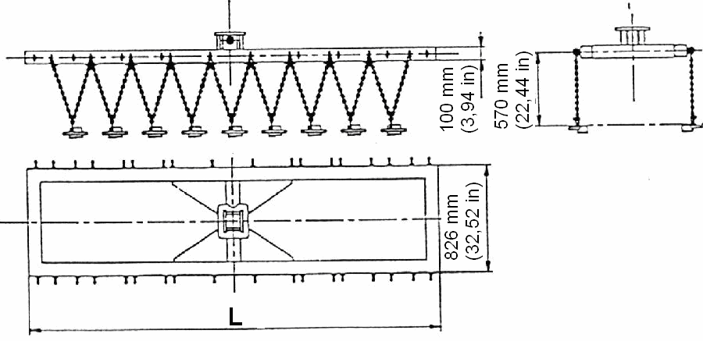

 | Tamping Unit | Table 12
 | Tamping Unit | Page 1/1
TYPE |  | RM 01
VIBRATION FREQUENCY | Hz | 35-45
WEIGHT | Kg  Lbs | 600  1320

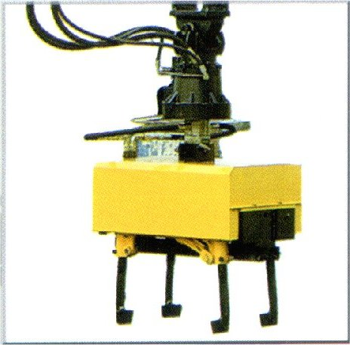
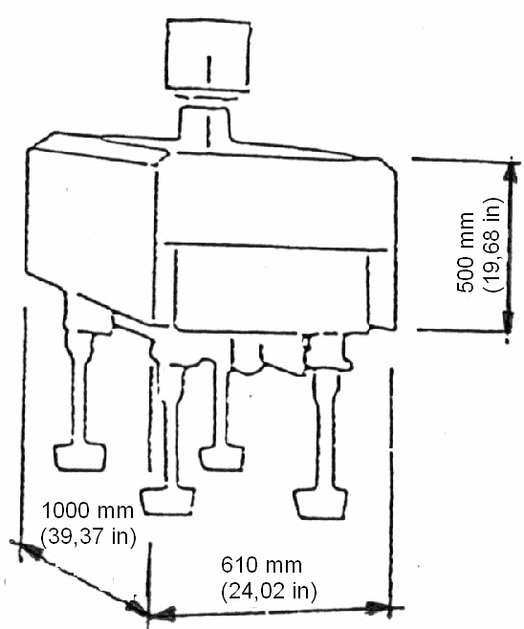

 | Magnet/Generator | Table 13
 | Magnet/Generator | Page 1/1
TYPE |  | ESM 95
POWER | Kw | 5.5
VOLTAGE | V | 220
DIAMETER | mm  In | 1050  41
WEIGHT | Kg  Lbs | 750  1650

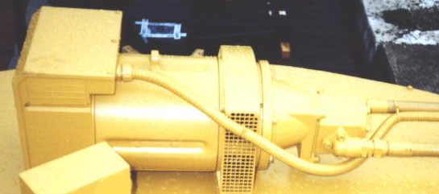

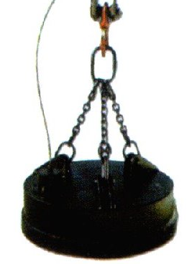

 | Hydraulic Breaker | Table 14
 | Hydraulic Breaker | Page 1/1
HI RAIL CRANE |  |  | T 2400 FS | T 4300 FS  T 7000 FS | T 10000 FS-S
TYPE |  |  | DMS 430 | DMS 740 | DMS 740
IMPACT ENERGY |  | J  ft-lbf | 1000  737 | 1350  1000 | 1350  1000
MAX. FREQUENCY |  | cpm | 900 | 900 | 900
TOOL DIAMETER |  | mm  in | 85  3.4 | 95  3.75 | 95  3.75
WEIGHT |  | Kg  Lbs | 450  990 | 740  1630 | 740  1630

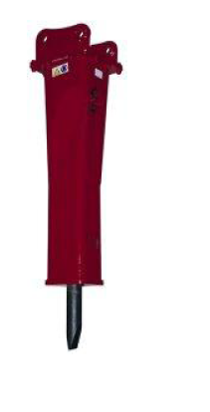

 | Ballast Broom | Table 15
 | Ballast Broom | Page 1/1
TYPE |  | SP 75
POWER | Kw  Hp | 27  36
WIDTH | mm  in | 2480  98
BROMM DIAMETER | mm  In | 750  30
WEIGHT | Kg  Lbs | 1700  3750

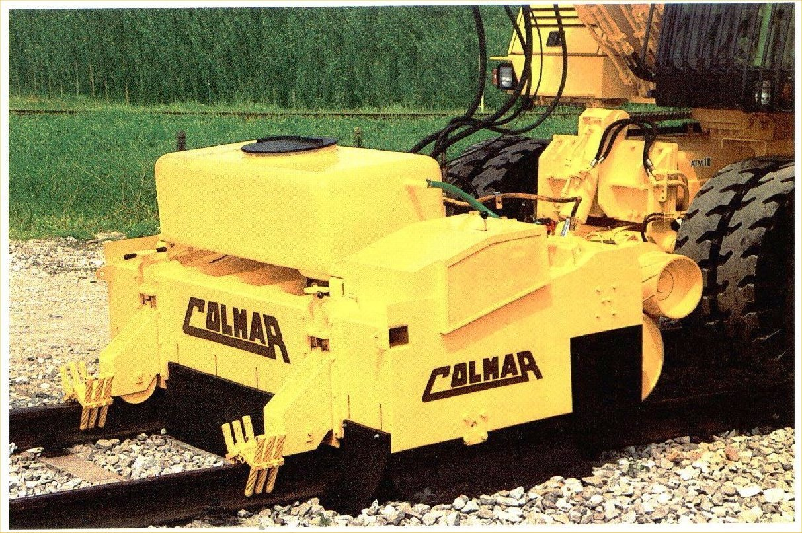

 | Pallets Handling Fork | Table 16
 | Pallets Handling Fork | Page 1/1
TYPE |  | R18
LIFTING CAPACITY | Kg  Lbs | 1800  4000
WEIGHT | Kg  Lbs | 180  400

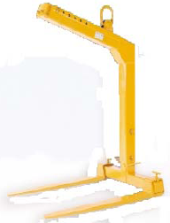

 | Grapple | Table 17
 | Grapple | Page 1/1
HI RAIL CRANE |  | T 2400 FS | T 4300 FS  T 7000 FS | T 10000 FS  T 10000 FS-S
TYPE |  | 450/5 | 600/5 | 600/5
CAPACITY | dm³  Cu yd | 450  0.6 | 600  0.8 | 600  0.8
WEIGHT | Kg  Lbs | 730  1600 | 1050  2300 | 1050  2300

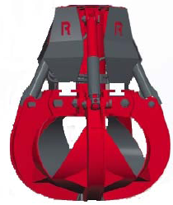

 | Drilling Device | Table 18
 | Drilling Device | Page 1/1
HI RAIL CRANE |  | T 2400 FS | T 4300 FS  T 7000 FS | T 10000 FS  T 10000 FS-S
TYPE |  | 400/18 | 600/18 | 600/18
AUGER DIAMETER | mm  in | 400  16 | 600  24 | 600  24
AUGER LENGHT | mm  in | 1800  70 | 1800  70 | 1800  70
TORQUE | daNm  Lbf ft | 295  2175 | 1800  13,200 | 1800  13,200
WEIGHT | Kg  Lbs | 270  600 | 480  1050 | 480  1050

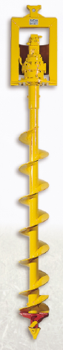

 | Offset Boom | Table 19
 | Offset Boom | Page 1/1
HI RAIL CRANE |  | T 2400 FS | T 4300 FS  T 7000 FS | T 10000 FS  T 10000 FS-S
 |  | YES | YES | NO

